# Mainframe VSAM Accounts and Customer Data Query Tool

## The Purpose

An organization has all of its customer and accounts data in VSAM Datasets on their IBM z Series mainframe. They want to make this data available to authorized employees to use AI to allow Natural Language queries to be made against the data.

## The Challenge

There are significant challenges to using data from Mainframe VSAM files:

1. Access to any mainframe resources are strictly secured and controlled.
2. VSAM cannot easily be integrated into an AI Process as the data is in a different code page and the technology is not directly accessible.
3. VSAM datasets do not have any meta data about the data included so this must be provided in the form of a COBOL Copybook or similar to correctly interpret the data.
4. The additional load from AI directly on these mainframe resources would not be acceptable from both a cost and performance perspective.

## The Configuration

Ostia and SnapLogic have developed the tools to automatically make this data available to be accessed from an AI Agent as follows:

1. Create a backup of the VSAM Data from each VSAM dataset.
2. Create a Snap Logic pipeline to….
   1. FTP The data from the mainframe.
   2. Process the data using the Cobol Copybook Snap and the appropriate COBOL Copybook for the backed up VSAM data.
   3. Process the data through an Embedder and upsert into a Pinecone database.

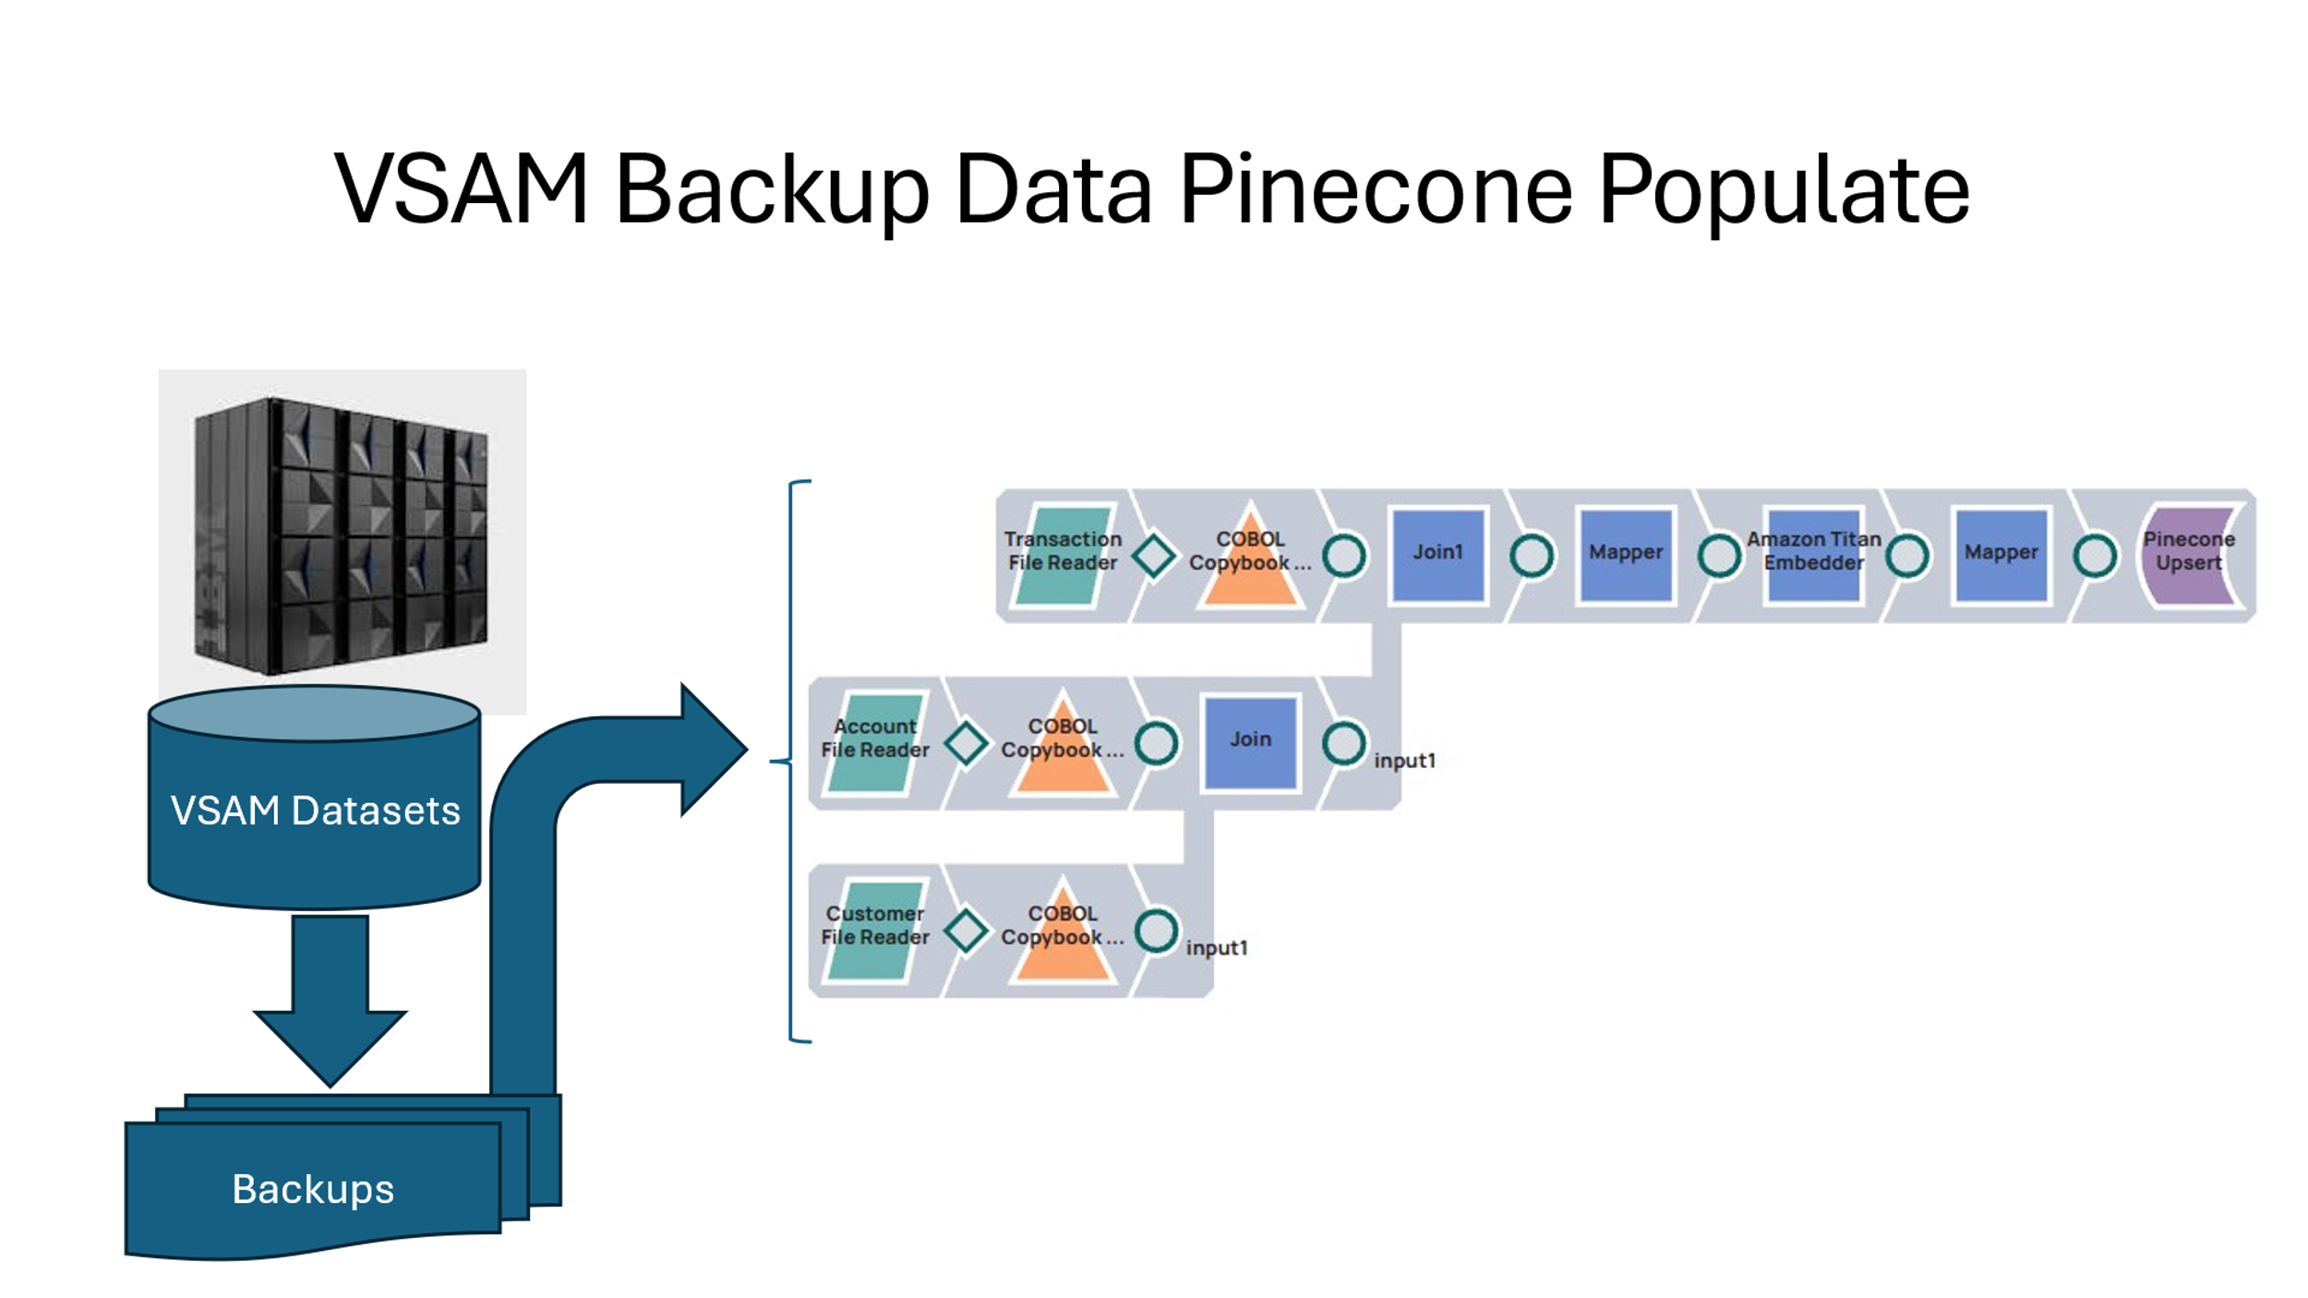

1. Once the data is loaded into the Pinecone database, it can be access using the AI Agent:

## Sample Queries

1. List all customers with a balance greater than 500 USD.
2. List all customer accounts in the Philippines.
3. List all accounts opened after January 2024.